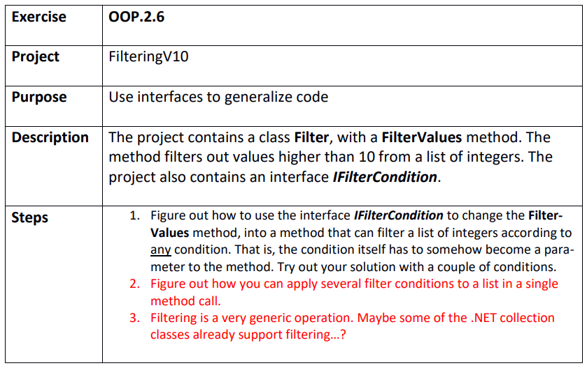

Step 1
FilteringV10.sln
We make a singleton class ValueOver10 that implements the interface:
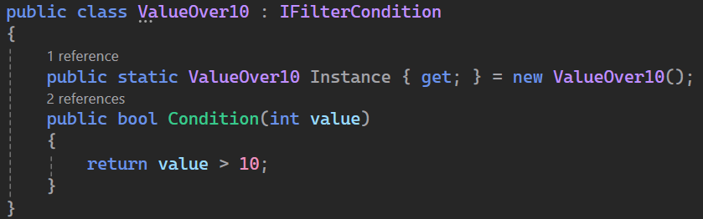
Then as parameter in the FilterValues we add IFilterCondition
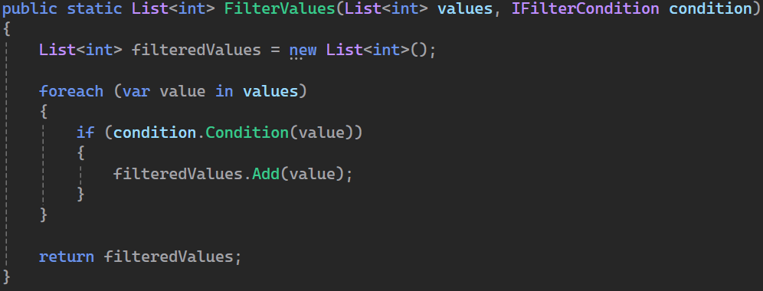

Step 2

